

**MIDDLE EAST TECHNICAL UNIVERSITY**

**EE493 STATIC POWER CONVERSIONS – I**

**TERM PROJECT SIMULATION REPORT**

**HAPPY EE FRIENDS**

**Atilla Can Aydemir 2374510**

**Arda Kasım 2232197**

**Eminalp Koyuncu 2307882**

**Introduction**

In this project, a DC motor will be driven with an adjustable input of at most 180V. This input is created by a system of three phase diode rectifier and buck converter.

**Topology Selection**

When all the topologies are considered, 3-phase diode full-bridge rectifier is selected. Single phase rectifiers are ruled out because of the high output ripple voltage and output voltage loss as seen in Figure 1. Using three-phase will increase the average output voltage and lower the ripples, while destroying the third harmonics completely. Three-phase full bridge rectifiers have low values of THD, which means fundamental component is more dominant over the higher order harmonics when compared to the single-phase rectifiers. Also, since each thyristor would need a gate driver signal, the resultant system would be very complicated. For the simplicity and the advantageous nature of it, three-phase full bridge diode rectifier topology is chosen. A total of 6 diodes will be used to realize this topology.

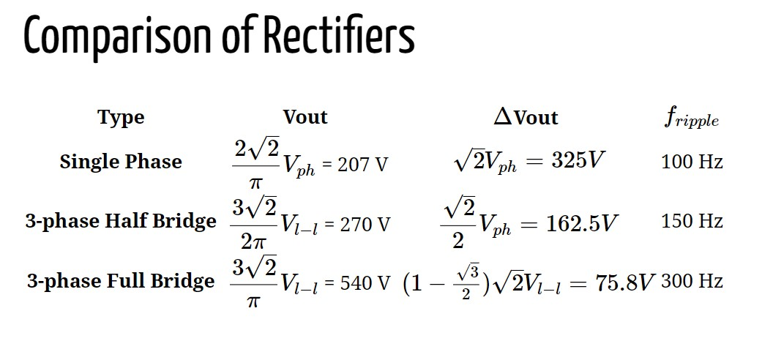

Figure 1 Comparison of Various Rectifier Topologies

After the creation of three phase diode rectifier, the output voltage is utilized to feed the input of the buck converter. The duty cycle of the buck converter is created by the 555 Timer this duty cycle determines the output voltage which is the input to the DC motor. It is required for the output of the buck converter to have at most 180V.

**Simulation Results:**

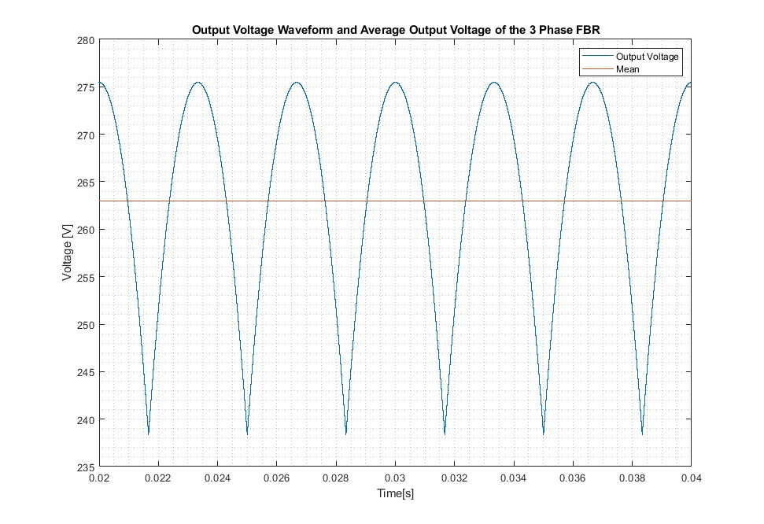

Figure 2 Three Phase Diode Rectifier Output Voltage Waveforms

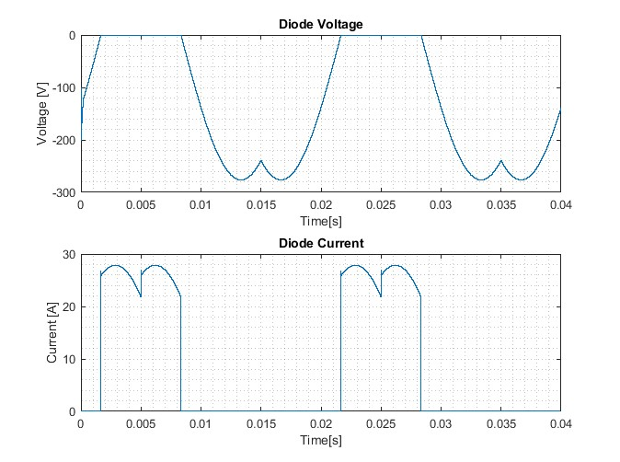

Figure 3 Rectifier Diode Voltages and Currents

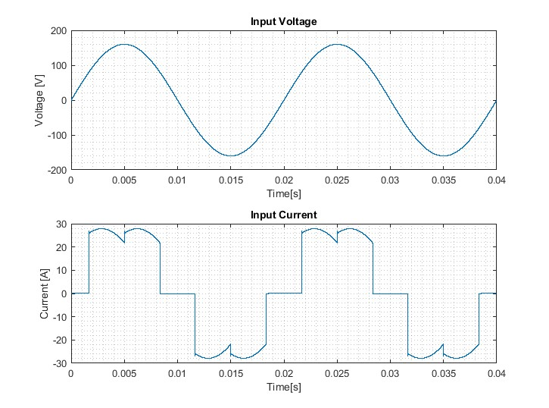

Figure 4 Input Voltage and Current Waverforms of Three Phase Full Bridge Diode Rectifier

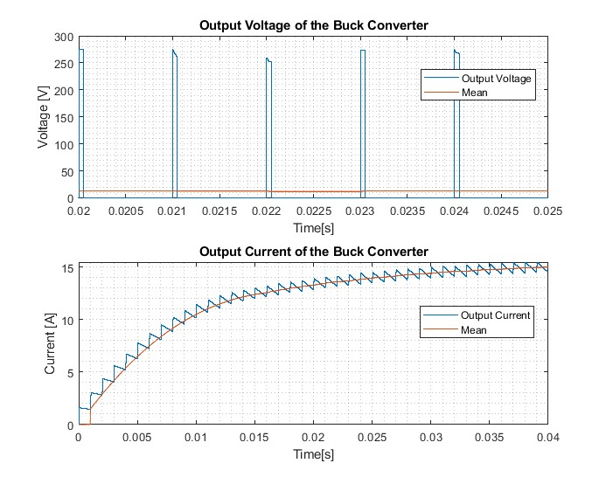

Figure 5 Buck Converter Output Voltage and Current Waveforms When Duty Cycle=0.05

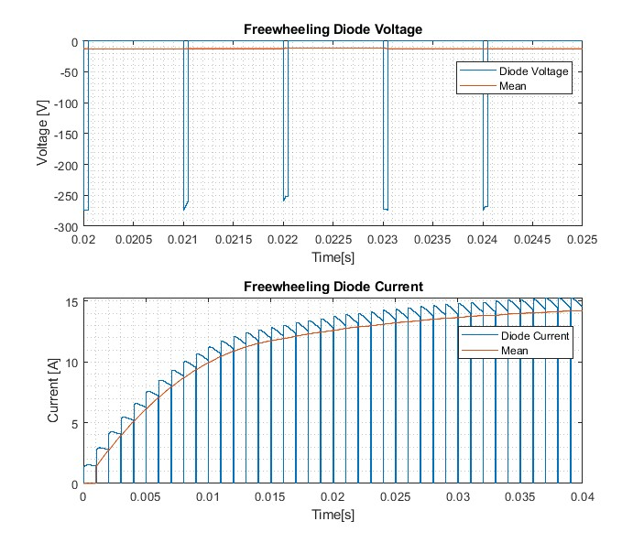

Figure 6 Freewheeling Diode and Current Waveforms When Duty Cycle=0.05

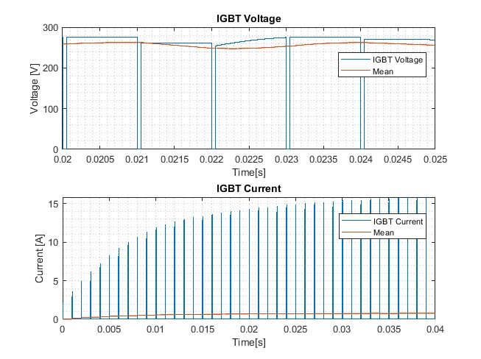

Figure 7 IGBT Voltage and Current when Duty Cycle=0.05

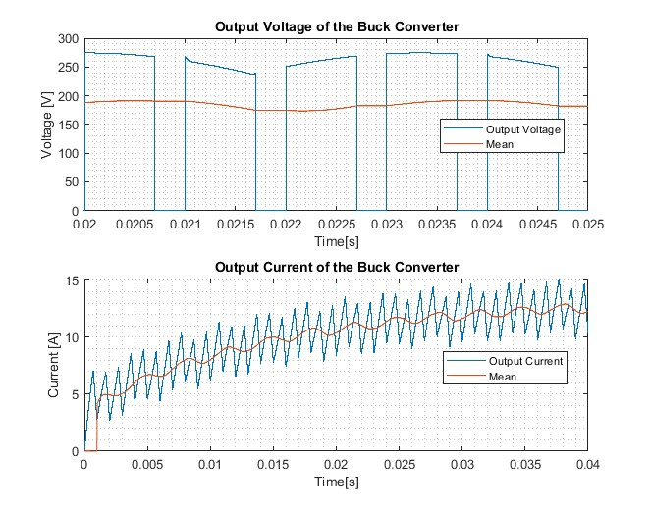

Figure 8 Buck Converter Output Voltage and Current Waveforms When Duty Cycle=0.7

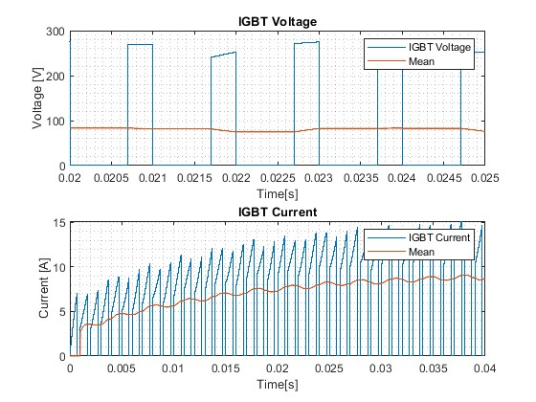

Figure 9 Freewheeling Diode and Current Waveforms When Duty Cycle=0.7

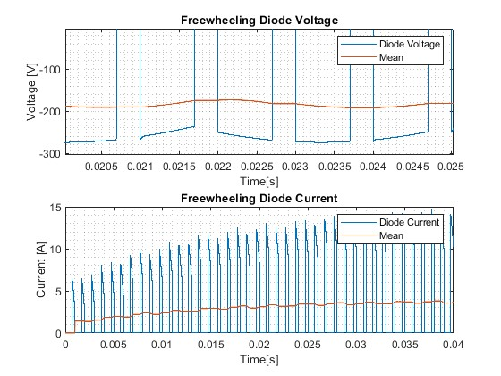

Figure 10 IGBT Voltage and Current when Duty Cycle=0.7

**Component Selection:**

Available components in the laboratory will be mostly used. The selection is based on the constraints of the project. The selected components by looking at the list on GitHub. LM555 Timer is used to create the PWM required for the buck converter. IXGH24N60C4D1 N Channel IGBT Transistor is used as the switch of the buck converter because none of the other components (MOSFETs) in the laboratory have safe margins of rated currents or voltages used in this system. A 25A fuse and fuse holder are chosen as safety. TO220 heatsink is chosen to dissipate the heat produced in the system because of the lossy components. MUR1560G power diode is used in the full bridge rectifier because of its ability to carry currents up to 15 A.

**Loss Analysis:**

In this system, there are switching and conduction losses of the diodes. Switching losses occur when the switching between on and off states occurs and they are proportional to the frequency of switching, reverse voltage, maximum reverse current and reverse recovery time. On the other hand, conduction losses occur when the diode is in forward conduction mode and its value depends on forward voltage and forward current values. Both can be formulized as:

**Notes:**

Capacitor can be used at load to decrease the voltage ripple even more

Buck converters for the PWM controller and 555 Timer

The Bonuses we aim for: Tea Bonus, PCB Bonus (Arda knows how to create a PCB), Industrial Design Bonus, Single Supply Bonus, Analog Controller (?), Closed Loop Voltage/Current Control Bonus, Closed Loop Speed Control Bonus (2 of the group member also take EE407), wide-bandgap semiconductor bonus (will look into it)